**Data Communication and Computer Networks**

**LAB # 03**



**Spring 2023**

Submitted by: **Safi Ullah Khan**

Registration No. : **20PWCSE1943**

Class Section: B

Submitted to:

**Engr. Yasir Saleem Afridi**

**Department of Computer Systems Engineering**

|  |  |  |  |  |
| --- | --- | --- | --- | --- |
| **Demonstration of Concepts** | **Poor (Does not meet expectation (1))**  The student failed to demonstrate a clear understanding of the assignment concepts | **Fair (Meet Expectation (2-3))**  The student demonstrated a clear understanding of some of the assignment concepts | **Good (Exceeds Expectation (4-5)**  The student demonstrated a clear understanding of the assignment concepts | **Score**  **30%** |
| **Accuracy** | The student mis-configured enough network settings that the lab computer couldn't function properly on the network | The student configured enough network settings that the lab computer partially functioned on the network | The student configured the network settings that the lab computer fully functioned on the network | **30%** |
| **Following Directions** | The student clearly failed to follow the verbal and written instructions to successfully complete the lab | The student failed to follow the some of the verbal and written instructions to successfully complete all requirements of the lab | The student followed the verbal and written instructions to successfully complete requirements of the lab | **20%** |
| **Time Utilization** | The student failed to complete even part of the lab in the allotted amount of time | The student failed to complete the entire lab in the allotted amount of time | The student completed the lab in its entirety in the al | **20%** |

**Contact Hours: 3**

**LAB ASSESSMENT RUBRIC**

## **OBJECTIVES OF THE LAB**

Following topics will be covered in this lab

* Understand the basic working of a Switch
* Implement the basic configuration of a switch using Packet Tracer.
* Saving the configuration files to flash for backup purposes.

ABOUT Switch:

A switch is a networking device that operates at the data link layer (Layer 2) of the OSI (Open Systems Interconnection) model. It connects multiple devices within a local area network (LAN) and allows them to communicate with each other by forwarding data packets between them.

The primary function of a switch is to receive data frames from one device and then selectively forward them to the appropriate destination device based on the Media Access Control (MAC) addresses of the devices. MAC addresses are unique identifiers assigned to network interface cards (NICs) of devices.

When a switch receives a data frame, it examines the destination MAC address of the frame and checks its MAC address table, which maps MAC addresses to specific switch ports. If the MAC address is found in the table, the switch forwards the frame only to the port associated with the destination device, improving network efficiency by reducing unnecessary traffic.

If the destination MAC address is not found in the table, the switch broadcasts the frame to all connected devices except the one it received the frame from. This process is called flooding. Once the destination device responds to the frame, the switch updates its MAC address table with the MAC address of the device and associates it with the appropriate port, allowing future frames destined for that device to be forwarded directly.

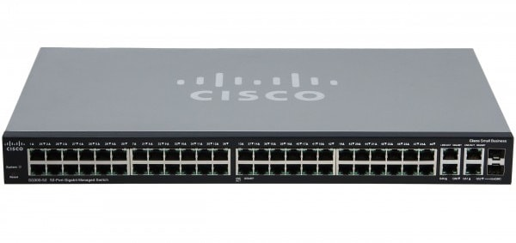

**Figure: A cisco Switch**

## Configuration Modes:

Cisco switches have different configuration modes that allow network administrators to make specific changes and configure various aspects of the switch. These configuration modes in Cisco switches provide a hierarchical structure that allows administrators to navigate through different levels of configuration and make appropriate changes to meet the network's requirements. It is essential to understand these modes to efficiently manage and customize the switch's configuration.

These modes are as follows:

1. **User EXEC Mode (User EXEC):** This is the default mode when accessing the switch. It provides limited access to basic monitoring commands, such as viewing system information and running diagnostic tests. The prompt in this mode ends with a ">" symbol.
2. **Privileged EXEC Mode (Privileged EXEC):** This mode provides a higher level of access and allows for more advanced configuration and management tasks. It enables commands such as configuring interfaces, viewing running configurations, and debugging. To enter this mode from User EXEC mode, you can use the "enable" command, and the prompt changes to end with a "#" symbol.
3. **Global Configuration Mode (Global Config):** This mode allows for making global changes to the switch's configuration. It allows you to modify settings that affect the entire switch, such as hostname, SNMP, security features, and routing protocols. To enter this mode from Privileged EXEC mode, use the "configure terminal" or "config t" command. The prompt changes to reflect the switch's hostname within parentheses.
4. **Interface Configuration Mode (Interface Config):** This mode is used to configure specific switch interfaces. It allows you to set parameters such as IP addresses, VLAN assignments, speed, duplex, and other interface-specific settings. To enter this mode from Global Configuration mode, use the "interface [interface-name]" command. The prompt changes to reflect the interface being configured.
5. **Line Configuration Mode:** This mode allows for configuring console, Telnet, or SSH access to the switch. It enables setting access control, authentication, and other line-specific parameters. To enter this mode from Global Configuration mode, use the "line [line-type line-number]" command, where line-type can be console, vty (for Telnet and SSH), or auxiliary.

**How to configure a Switch in Packet Tracer**

By following the steps given below, one can configure a switch using Cisco Packet Tracer

**Step 1: Cable the network as shown in the topology.**

1. From the shelf, click and drag switch S1 and place it on the left side of the table.
2. From the shelf, click and drag the device PC-A and place it on the right side of the table. Power on PC-A.
3. Connect a console cable from device PC-A to switch S1, as shown in the topology. Do not connect the device PC-A Ethernet cable at this time.
4. From the Desktop tab of PC-A, use Terminal to connect to the switch.

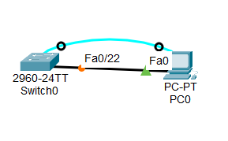

**Figure: Network topology**

EXEC MODE:

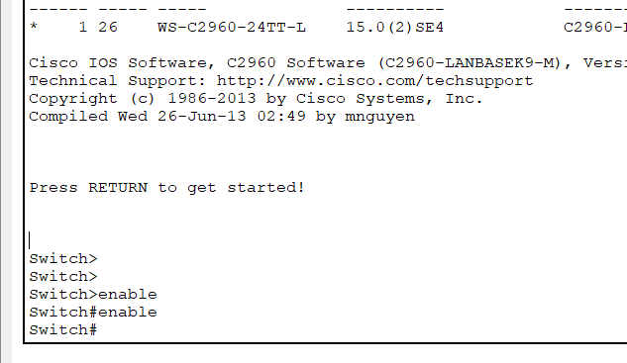

SHOW RUNNING CONFIG:

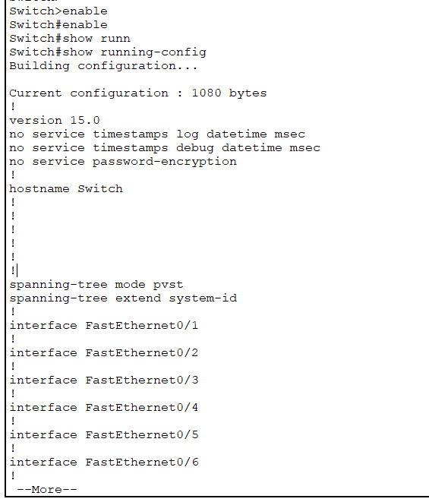

Config terminal:

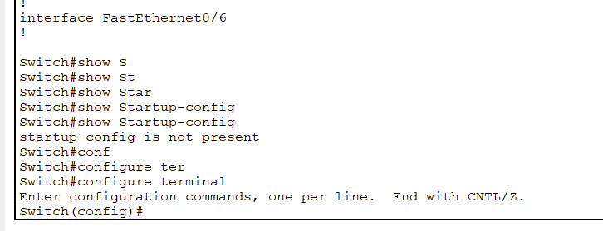

HOSTNAME:

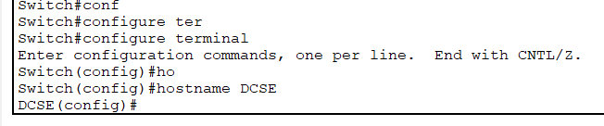

Password:

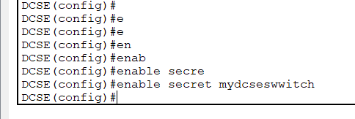

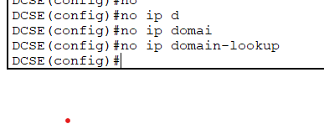

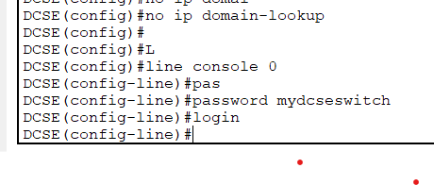

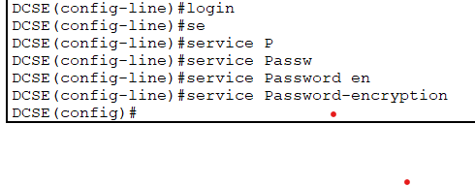

**Conclusion:**

Access the command-line interface (CLI) of the switch and enter privilege mode.

Set the hostname of the switch using the hostname command.

Configure a password for privilege mode using the enable secret command for enhanced security.

Disable domain lookup to avoid delays caused by DNS resolution when entering incorrect commands.

Set a password for the console port using the line console 0, password, and login commands.

Enable password encryption with the service password-encryption command to protect passwords stored in the configuration.

Set a banner message using the motd command to provide notices or warnings to users.

Save the configuration changes by using the copy running-config startup-config command in user privilege mode.